## Overview

In this activity, you will create a hero section layout using Webflow’s native components and make the design responsive.

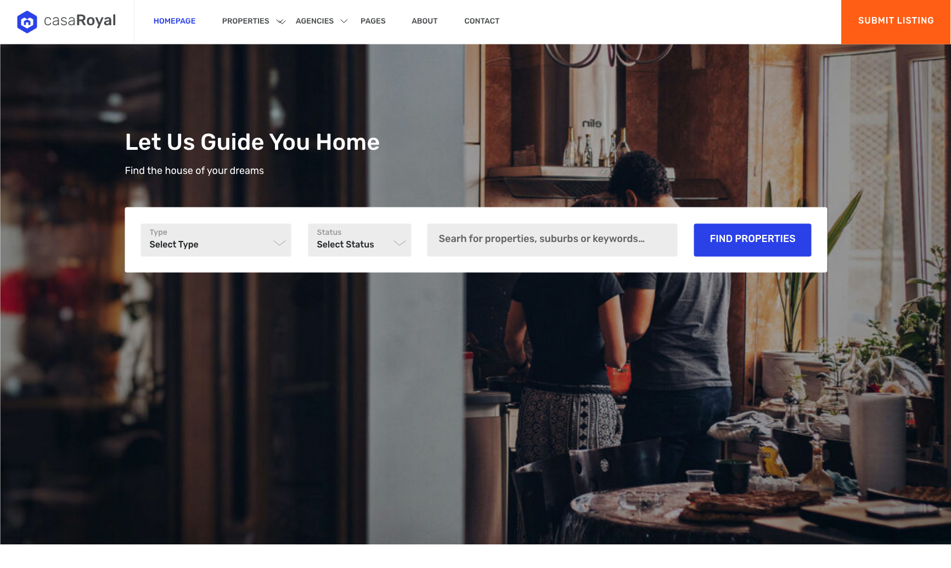

## Instructions

1. Download the 02-casaroyal-real-estate-above-the-fold.xd file from the Activities folder.
2. Using one of your existing projects, add a new page by clicking the Create New Page icon.

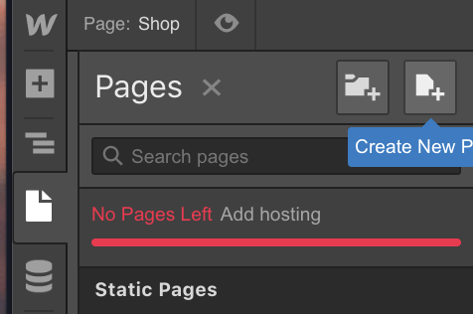

* 1. Note: You may need to delete a page or a project.

1. On your new page, navigate to the Elements panel. Scroll down to components.  
   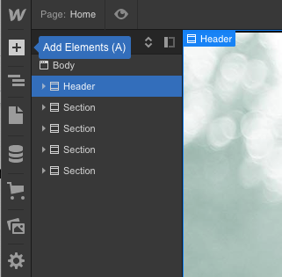
2. Add a navbar component to your canvas.
   1. 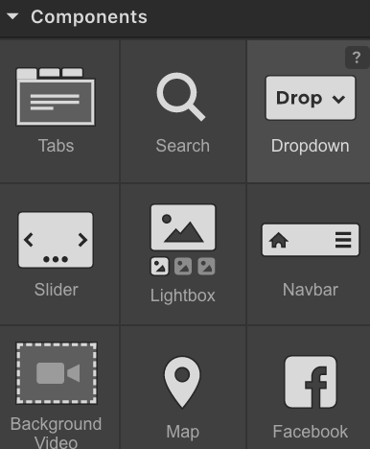
   2. Customize the design to match the XD file:



* 1. Customize the navbar on the mobile breakpoint.
     1. Select the mobile version
        1. 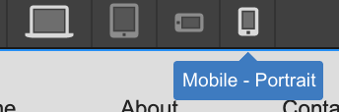
     2. Customize the styles to match that of the mockup below.
     3. 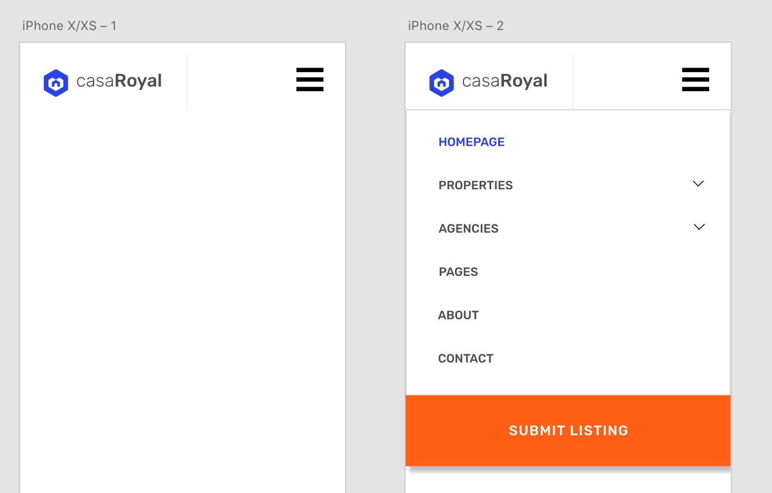
  2. Add a new section.
     1. Add a slider component to your section.
        1. 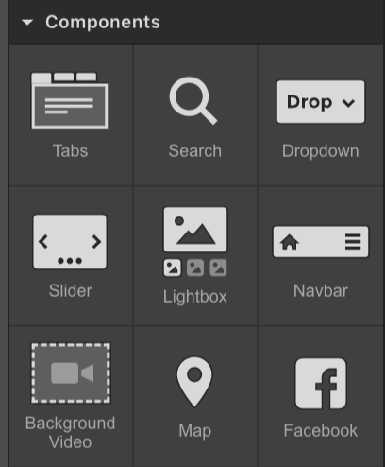
     2. Your navigator should look like this:
        1. 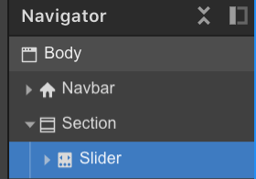
     3. Customize the slider to match the design from the XD file.
     4. Make the slider responsive once you complete the desktop.